**Name: DE LA GENTE. FRANCHESCA C.**

1. Display employees sorted by firstname in ascending order.

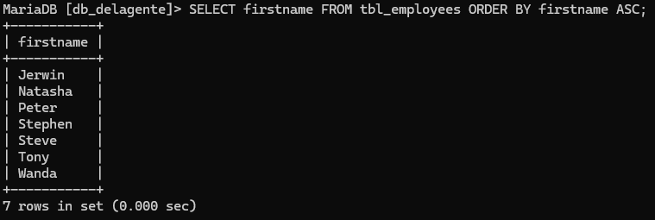

1. Display employees sorted by salary in descending order.

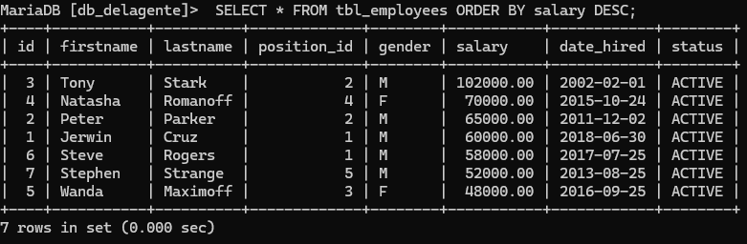

1. Show employees sorted by date_hired (oldest first).

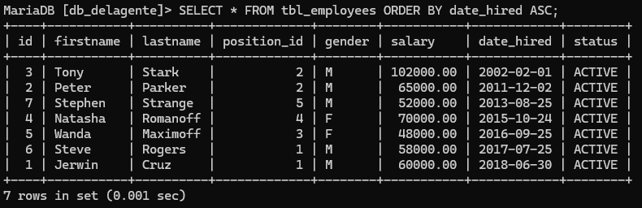

1. Count how many employees are in each position_id.

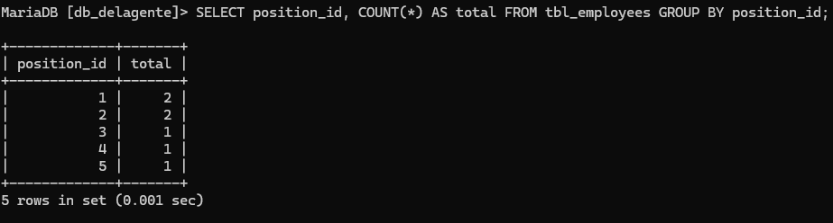

1. Count how many employees are grouped by gender.

